Subjected to Dr. Maher Abdelrasoul

Electronics 2

|  |  |
| --- | --- |
| 231903633 | جورج اميل صادق ساويرس |
| 231903753 | زياد عبدالحكيم عبدالمقصود |
| 231903549 | كنزى وليد سرور |

**The components :**

• 12V power supply

• 1k resistor (labeled R1)

• 470uF capacitor (labeled C1)

• 1kΩ resistor (labeled R2)

• 1uF capacitor (labeled C2)

• 220uF capacitor (labeled C3)

• NE555 timer IC

• TIP142 transistor

• 50kΩ potentiometer (labeled VR1)

• 10kΩ potentiometer (labeled VR1)

• 1N4148 diode (labeled D1)

• Motor (M)

• 104 ceramic capacitors (labeled C3 and C4)

# **Circuit schematic :**

# 3D design:

# **Breadboard:**

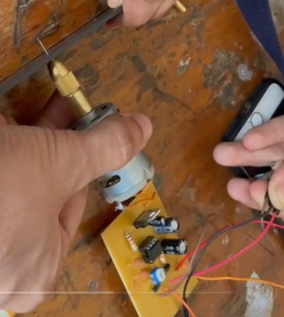

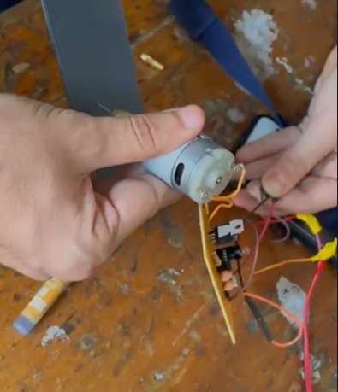

**Duty cycle wave = (R1 + R2) / (R1 + 2 * R2)**

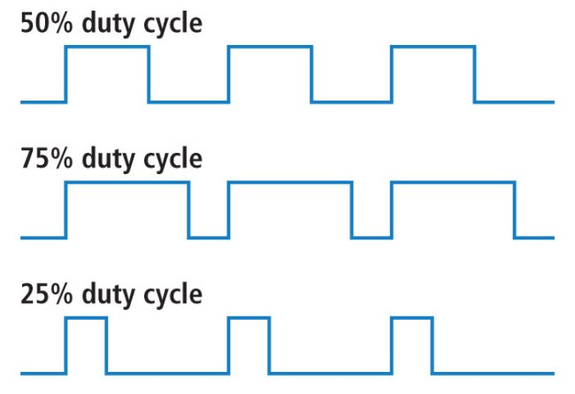

So the duty cycle of our circuit is :

From the above relation =

**Frequency of the circuit:**



So the frequency of our circuit is From the above relation: